**Project 5370**

*BN, Nov, 2018*

Project 5370 - This project will pull the invoices paid and calculate the commission for a Sales Person. *Customer: Controlled Fluids, Inc.  
Accounts Receivable > Reports > Commision Report 5370*

Commision amount = Gross Profit * V_Commission_Rate.Commission_Rate % * Invoice Payment Percentage.  
As AR_Open_Items is sometimes a big table, so we use Cutoff starting date recommended as 3 years prior to the current date, to calculate the accumulated payments and get the last payment date for each invoice

Specs:  
User will select:  
    a.Cutoff date (default as 3 years from current date): this date will let the program not process the unnecessary calculations.  
    b. 100% paid: Only pull the invoices that has been paid 100% (not less, not more).  
    c. Last payment date range: this date range will tell the program to pull only invoices which the last payment date falls into that date range.  
    d. Sales Rep to run the report for. Manager can run report for every/All Sales Rep. Otherwise the Sales Rep can only run the report for himself.  
        There is a maintenance program that map the GSS User ID with Sales Person ID. Manager are users that are in security group COMMAN.  
    e. Option to run the Crystal Report after the dashboard has been generated. The customer wanted the Crystal Report, but later they liked the dashboard more, so we stopped making change to the crystal report.

**1/User maintenance program**

Controlled Fluids, Inc assigned Sales Reps user ID of GSS.

This is a maintenance program for the User ID – Sales ID relation. If a user is a Sales Rep, when he launches the commission report program, it will identify their Sales Rep ID.

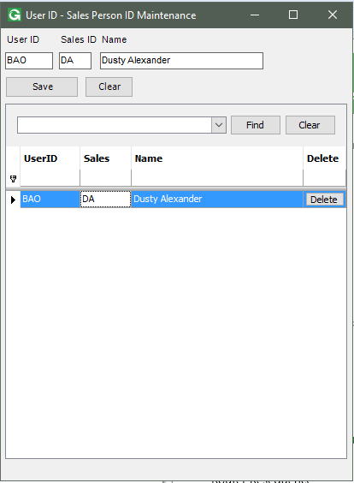

**2/ Accounts Receivable > Reports > Commision Report 5370**

User will select:  
    a.Cutoff date (default as 3 years from current date): this date will let the program not process the unnecessary calculations.  
    b. 100% paid: Only pull the invoices that has been paid 100% (not less, not more).  
    c. Last payment date range: this date range will tell the program to pull only invoices which the last payment date falls into that date range.  
    d. Sales Rep to run the report for. Manager can run report for every/All Sales Rep. Otherwise the Sales Rep can only run the report for himself.  
        There is a maintenance program that map the GSS User ID with Sales Person ID. Manager are users that are in security group COMMAN.  
    e. Option to run the Crystal Report after the dashboard has been generated. The customer wanted the Crystal Report, but later they liked the dashboard more, so we stopped making change to the crystal report.

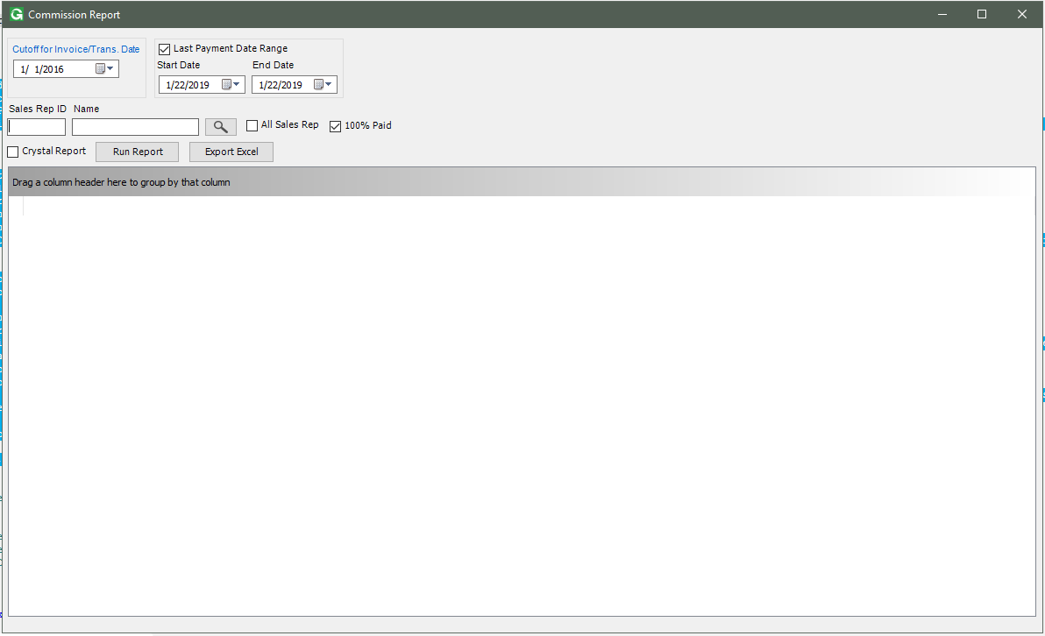

If Amt Paid cell is clicked, the program will open the Payment History for the underlined Invoice.

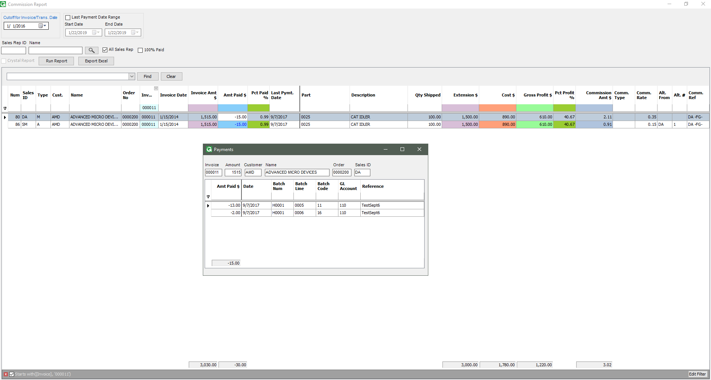

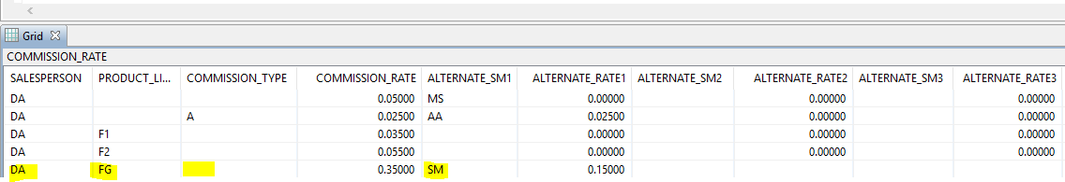

We can see the data in a dashboard. If we check the Crystal Report checkbox, a report will be generated:

